**Centre Name: ACE-HCMC-2-FPT.**

**Address: 590 Cach Mang Thang 8, District 3, Ho Chi Minh City, Viet Nam.**

**Vehicle Insurance Management**

|  |  |  |
| --- | --- | --- |
| **Supervisor:** | Mr. Le Tuan Xuyen | |
| **Semester:** | 3 | |
| **Batch No:** | T1.2208.A2 | |
| **Group No:** | 2 | |
| **Order:** | **Full name** | **Roll No.** |
| 1. | **TRƯƠNG TẤN PHÁT** | **Student1409158** |
| 2. | Nguyễn Hoàng Gia Phúc | Student1408029 |
| 3. | Nguyễn Trọng Tiến Đức | Student1409132 |
| 4. | Phùng Thị Thùy Linh | Student1408057 |

* **This is to certify that**

**Mr.** Truong Tan Phat .

**Mr.** Nguyen Hoang Gia Phuc .

**Mr.** Nguyen Trong Tien Duc .

**Mr.** Phung Thi Thuy Linh .

**have successfully designed & developed:**

eProject:

* **Submitted by:**

Mr. Le Tuan Xuyen

**Date of issue:** 29/11/2023

**Authorized Signature:**

# 

# 

# REVIEW 1

## Introduction

I'd like to thank you everyone on behalf of Group 2 for your efforts and support in bringing this eProject to a successful conclusion. We received a lot of assistance from our teacher, Mr. Le Tuan Xuyen, starting on the first day of Sem 3 at FPT Aptech. He has led us in this eProject with his zeal and discipline, and it is thanks to him that we will be able to complete this project. Therefore, Mr. Xuyen, let me say once more how much we appreciate your commitment and leadership.

In addition, I want to thank the entire group 2 team for their dedication to finishing this project over the course of four weeks.

Last but not least, we would like to express our gratitude to the Aptech eProject team for giving us the chance to put what we had learned into practice and obtain practical experience that would be valuable for our future careers.

## Synopsis:

The Objective of this program we aim is to give a sample project to work on real life projects. These applications help us build a larger, more robust application.

The objective is not only to teach us C Sharp, .Net, ReactJS but also to provide us with a real life scenario and help us create basic applications using the tools. We can enhance our skills and value with the project.

We are a reputable company providing suitable security solutions for vehicle insurance businesses.

It is very essential for us to have a clear understanding of the subject. We think we should go through the project and solve the assignments as per requirements given.

## Customer's Requirement Specifications

There is a need for a website that can sell insurance contracts to users in the fastest and most convenient way. with the main required functions detailed mentioned below.

### Home Page:

#### The site should have menu categorising required functionalities:

1. **About us**
2. **Types of insurance**
3. **Testimonials**
4. **Site map**
5. **Contact us**

#### There should be 2 logins as mentioned below:

- Customer:

* 1. User needs to register as customer by providing the necessary information in the registration form and provide the user name and password

1. Customer can login with unique user name and password.
2. He can change the password.
3. Can purchase the policy online: For purchasing the policy online, he has to fill in the application form which would capture all the required
4. Information about the vehicle. On successful payment, copy of policy would be generated which customer can save for the records.
5. Initiate the claim by filling the claim form.

- Employee:

* 1. Employee will be admin who can login with admin user name and password.
  2. He can perform all the admin functions as maintaining the police records, claim records, payment schedules etc
  3. Following reports needs to be generated

i. Monthly sell of policies

ii. Vehicle wise analysis

iii. Claims report

iv. Policies due renewals

v. Policies lapsed report

## System Requirement Specifications

The Guest accessing the website for the first time can register right away or just search for a product but lack service. When they want to actually buy a product and pay for it, they need to register to become a customer then all of the service will be available.

### Server requirements:

#### Hardware:

|  |  |
| --- | --- |
| Component | Requirement |
| CPU | Processor type:  Pentium III-compatible processor or faster  Processor speed:  Recommended: 1.0 GHz or faster |
| OS | All OS(Windows ,Linux ,Android ,Mac OS …) |
| Memory (RAM) | RAM:  Minimum: 1 GB  Recommended: 2 GB or more  Maximum: Operating system maximum |
| Hard Drive | Free space:  Minimum: 10 MB |

#### Software:

|  |  |
| --- | --- |
| Component | Requirement |
| Web Browser | IE 8.0 , Firefox 3.0,Chrome or Higher….. |

### Development Software:

Microsoft SQL server Management Studio

Microsoft Visual Studio 2022

### Technology:

ASP.Net Core 6.0

Entity Framework Core 6.0

React 18.0.2

## TASK SHEET REVIEW 1

|  |  |  |  |  |  |  |  |
| --- | --- | --- | --- | --- | --- | --- | --- |
| **Project Ref. No.:**  **eP/Advertisement** **Portal Management** **System/01** | | **Project Title:** | **Activity Plan** **Prepared** **By:** | **Date of Preparation of Activity Plan:** | | | |
| **Sr.No.** | **Task** | **Actual Start** **Date** | **Actual** **Days** | **Team** **Mate** **Names** | **Status** |
| 1 | Introduce | LetUsProtectYourCar | Truong Tan Phat | 03/12/2023 | 1 | PHAT | Completed |
| 2 | Problem Definition | 03/12/2023 | 1 | PHUC | Completed |
| 3 | Requirement & Non-functional requirement | 03/12/2023 | 1 | DUC | Completed |
| 4 | Process Analyst & Task sheet review | 03/12/2023 | 1 | LINH | Completed |

# REVIEW 2

## Architecture & Design of the Project





**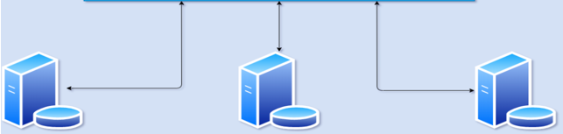******

### Presentation

Exposes interaction capabilities for the end users or applications / systems wanting to interact with it.

Interacts with the Business Logic layer.

Can interact with other applications (through their presentation layers).

### Business Logic

Expresses domain knowledge, to be utilized from the Presentation layer.

Interacts with the Data Access layer.

Can interact with other applications (through their presentation layers).

### Data Access

Acts as a data persistence, to be utilized from Business Logic.

Can interact with other applications (through their presentation layers).

## Algorithms – Data Flowchart

### Symbol generates:

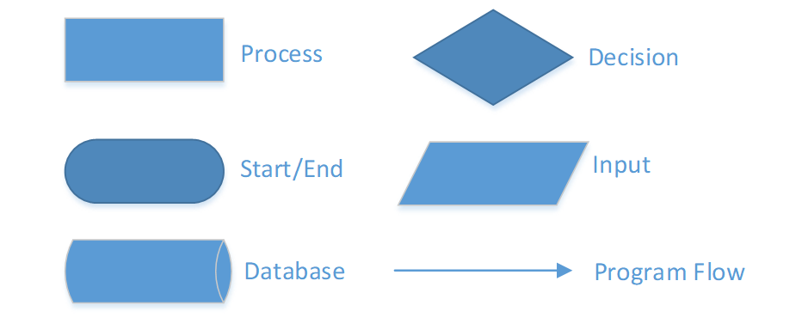

### Main data flowchart for users

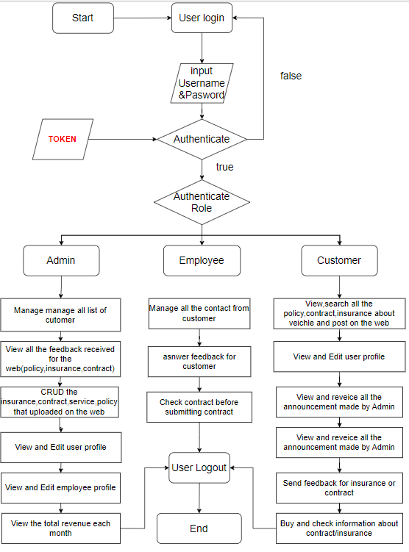

### 

### 3.Login process (For admins and members)

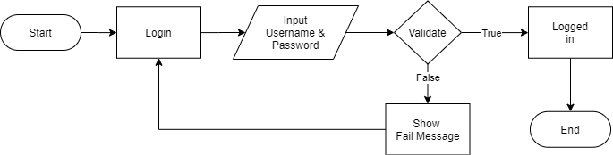

### 4.Logout process (For admins and members)

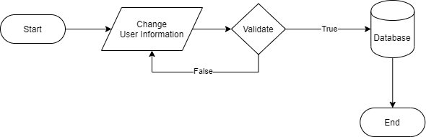

## Use Case Diagram

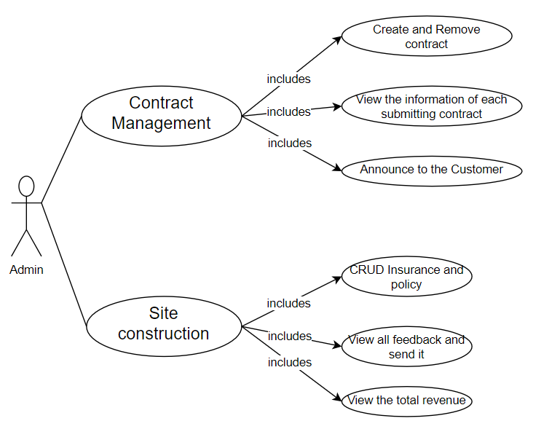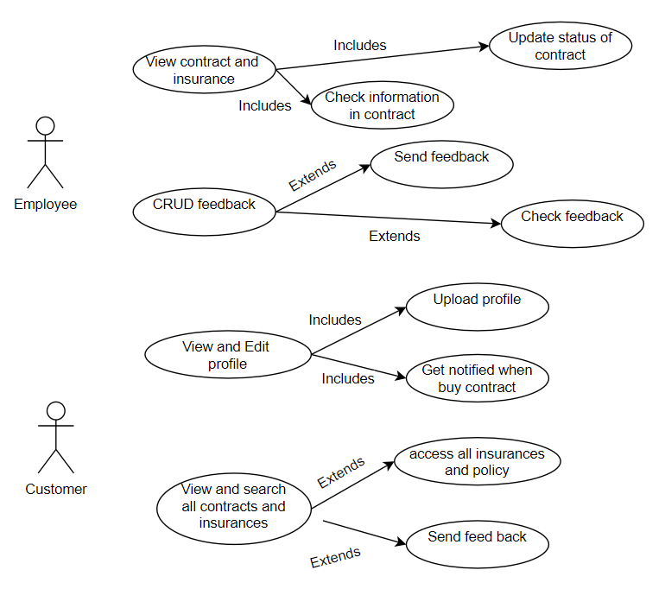

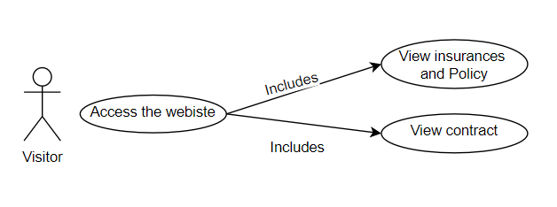

## 

## A screenshot of a computer Description automatically generatedEntity – Relationship Diagrams

# TASK SHEET REVIEW 2

|  |  |  |  |  |  |  |  |
| --- | --- | --- | --- | --- | --- | --- | --- |
| **Project Ref. No.:**  **eP/Advertisement** **Portal Management** **System/01** | | **Project Title:** | **Activity Plan** **Prepared** **By:** | **Date of Preparation of Activity Plan:** | | | |
| **Sr.No.** | **Task** | **Actual Start** **Date** | **Actual** **Days** | **Team** **Mate** **Names** | **Status** |
| 1 | Architecture & Design of Project | Star Security Service | Nguyễn Hoàng Gia Phúc,  Trương Tấn Phát | 06/12/2023 | 1 | PHAT | Completed |
| 2 | Algorithms – Data Flowchart | 06/12/2023 | 1 | PHUC | Completed |
| 3 | Use Case Diagram & Task sheet review | 06/12/2023 | 1 | DUC | Completed |
| 4 | Entity-Relationship Diagram | 06/12/2023 | 1 | LINH | Completed |

|  |  |
| --- | --- |
| **Date: 06/12/2023** | |
| **Signature of Instructor:**  **Mr. LE TUAN XUYEN** | **Signature of Team Leader:**  **TRUONG TAN PHAT** |

# REVIEW 3

## Site map

### Client site map

### Dashboard site map

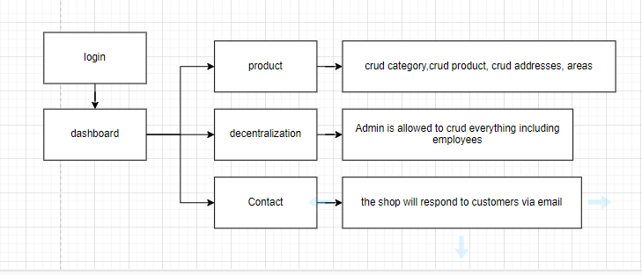

## Graphical User Interface (GUI) design

### Client GUI

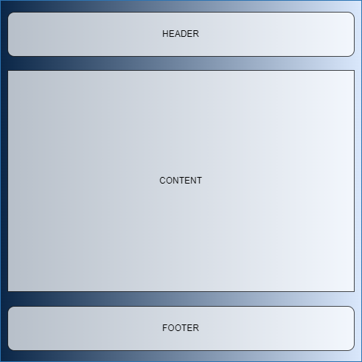

#### Home page (Index)

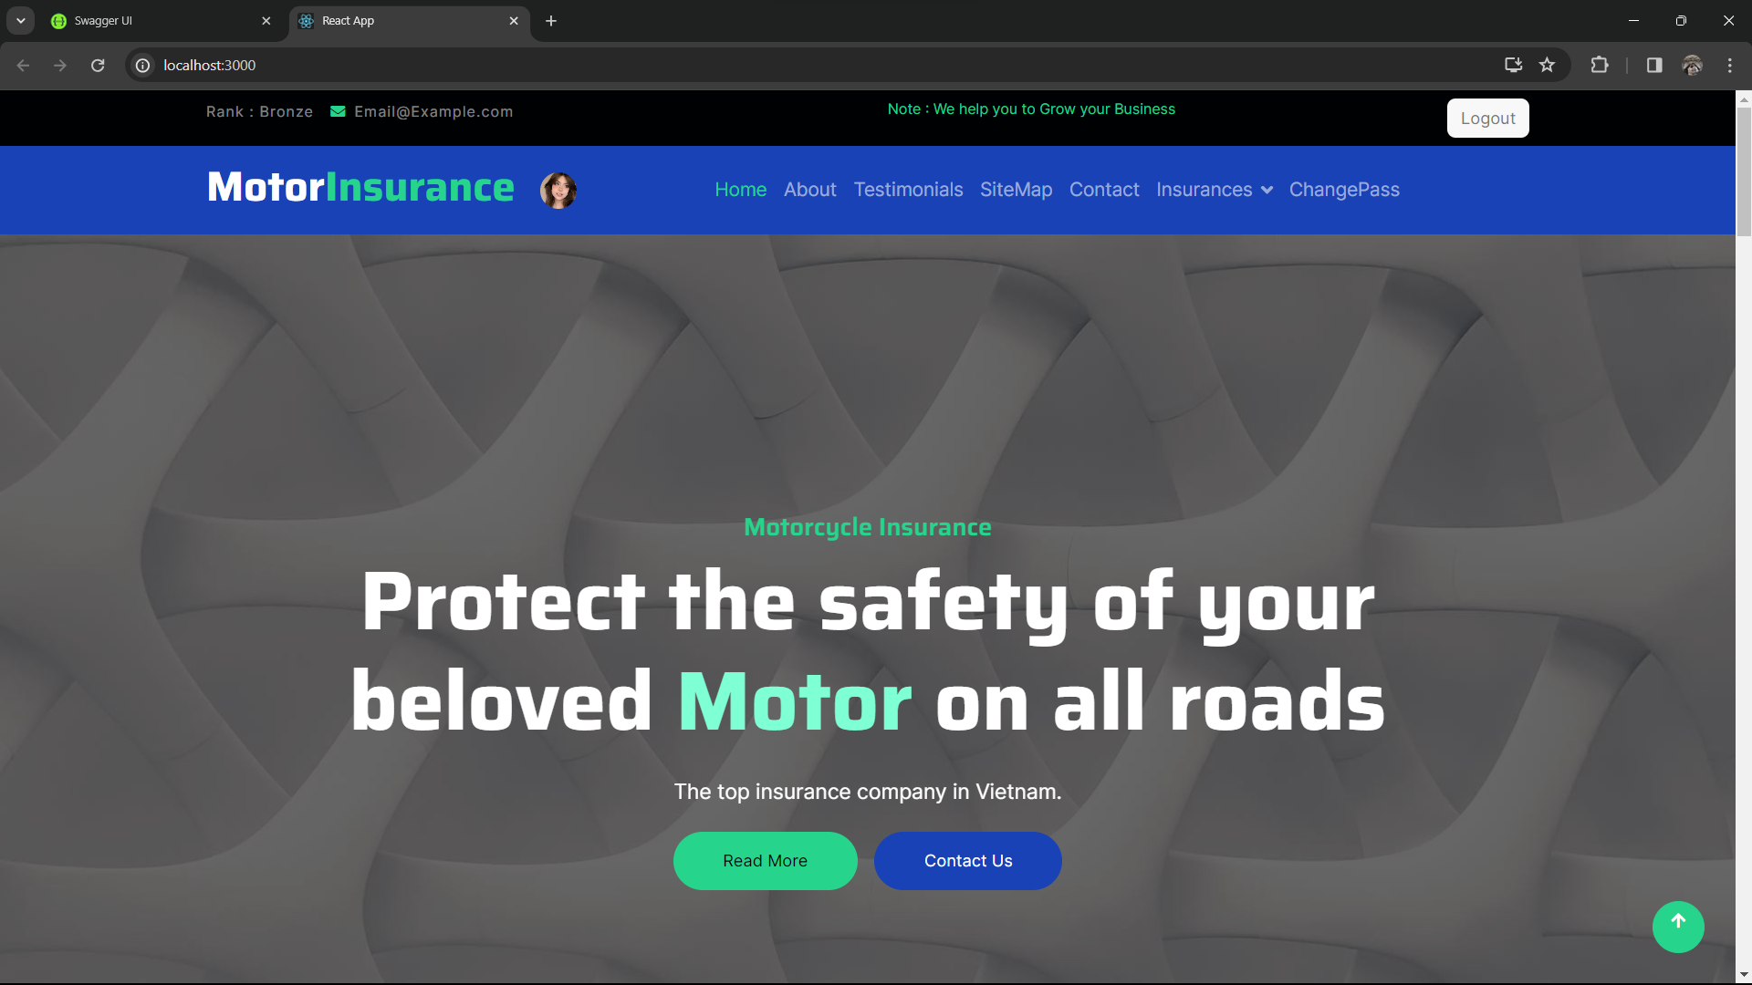

#### Contact page

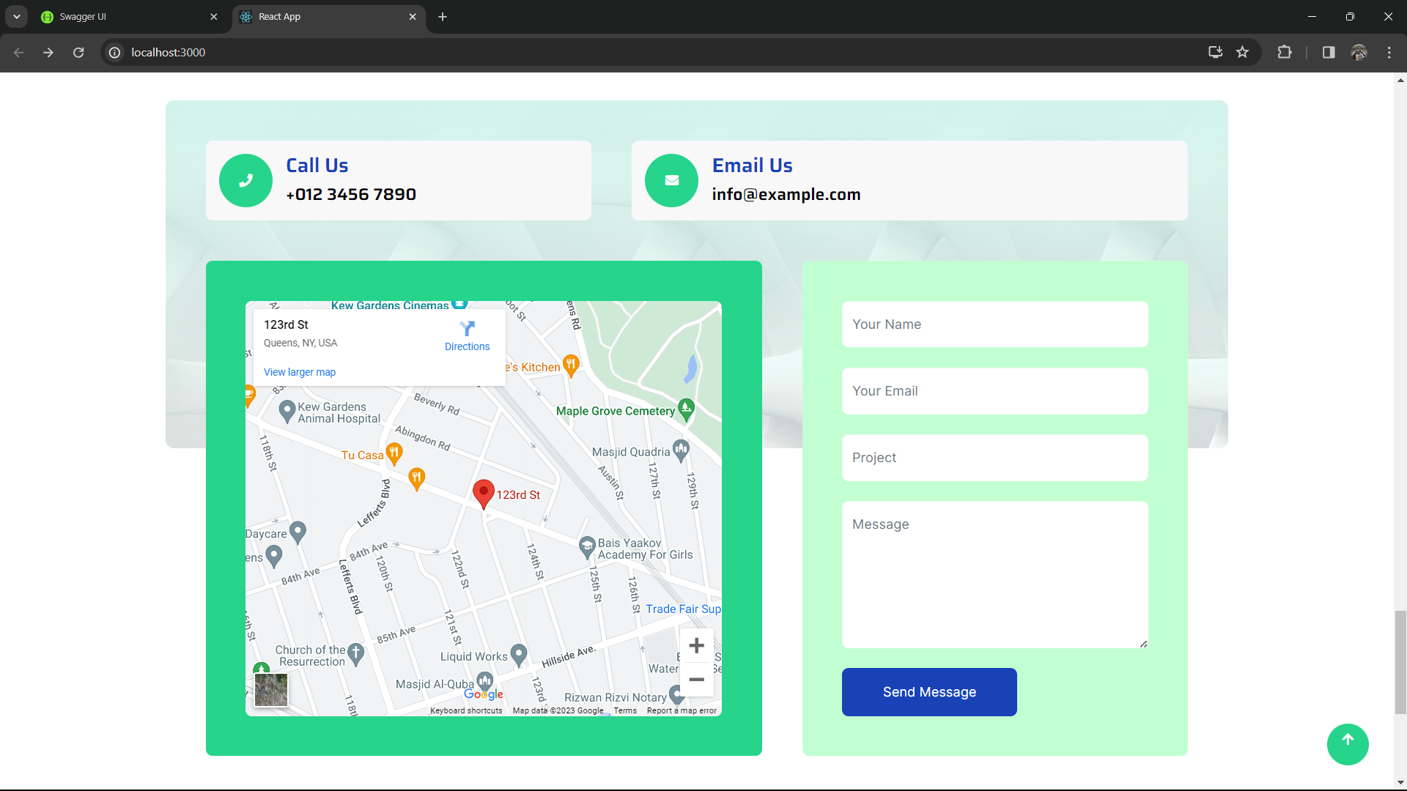

#### About us

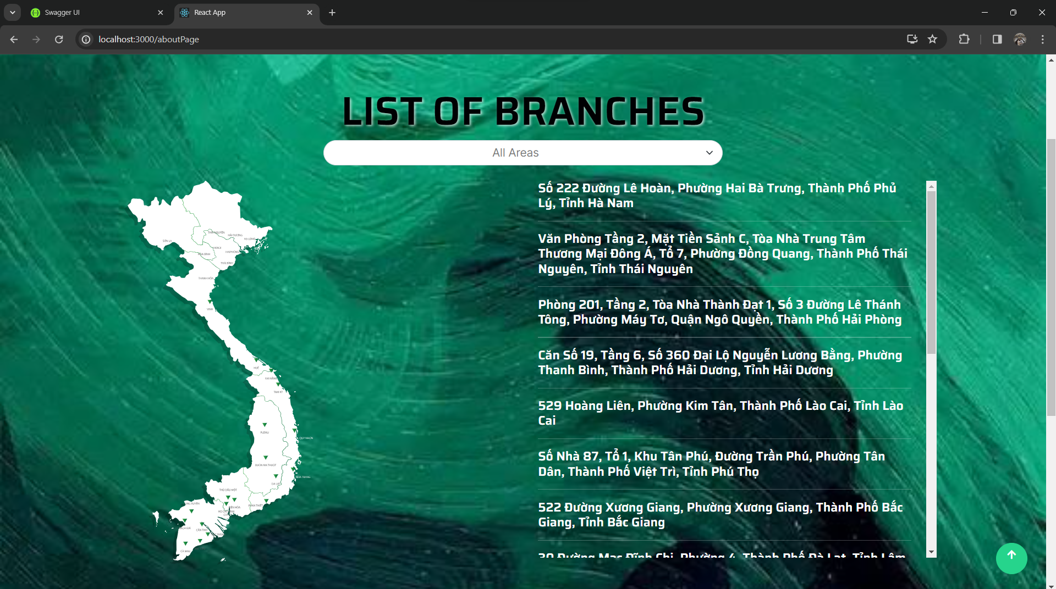

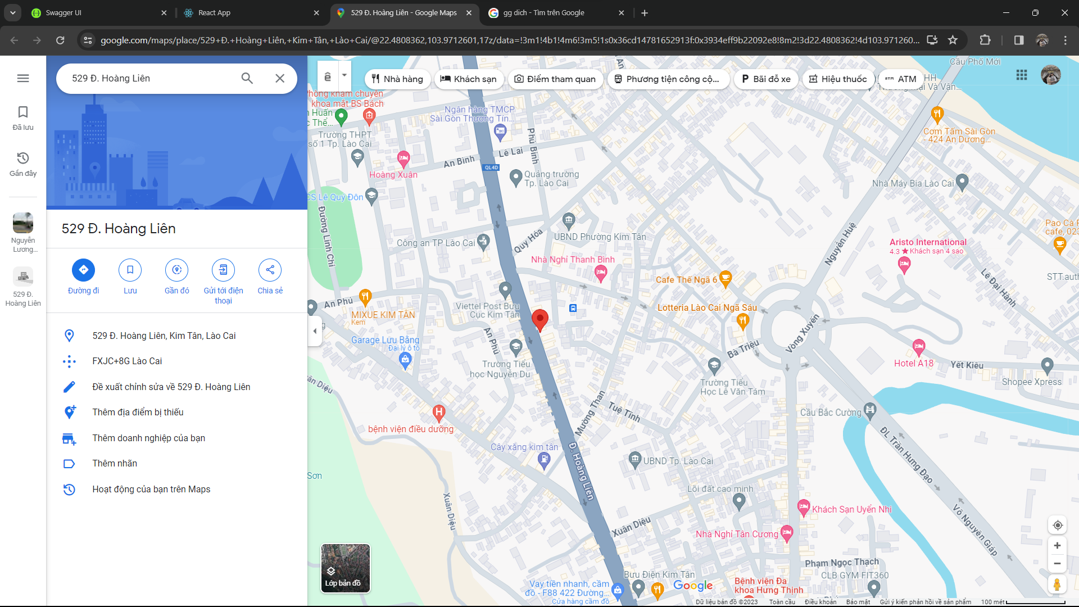

#### Sign up

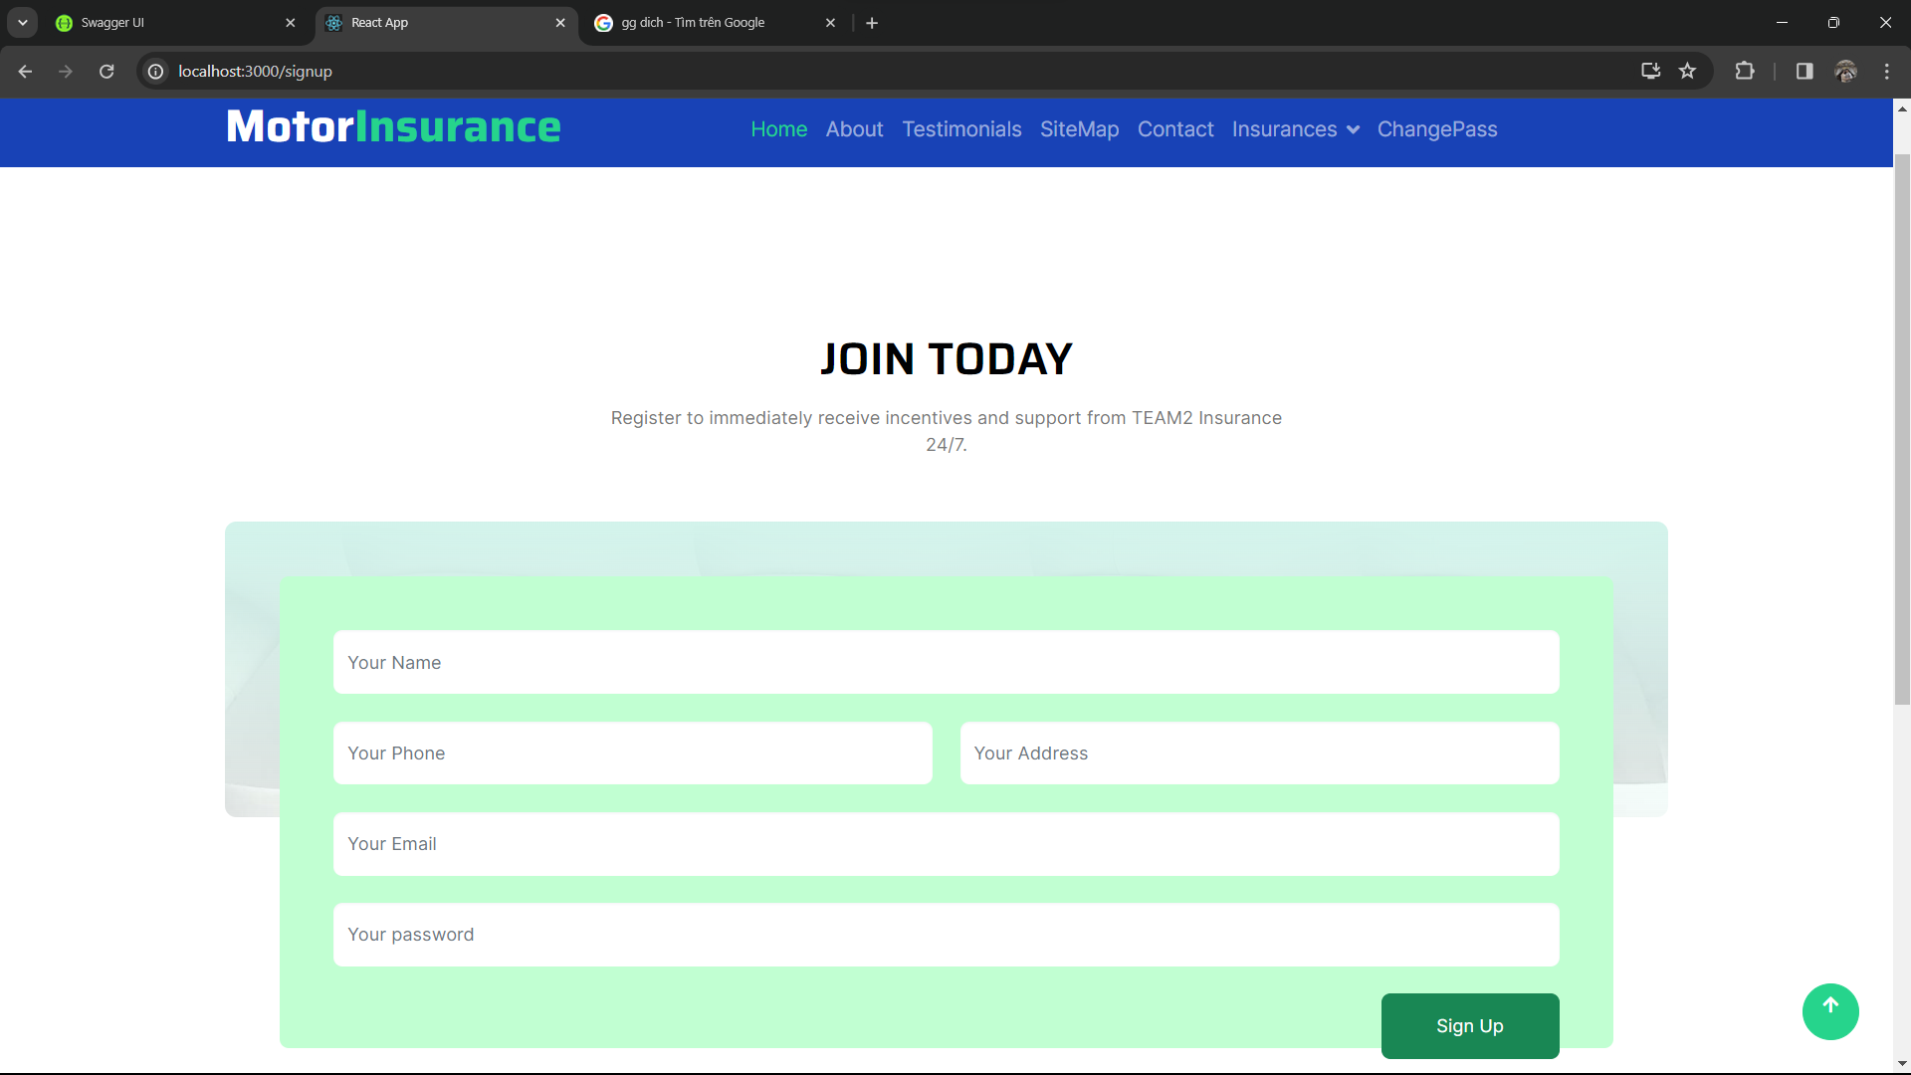

#### Login

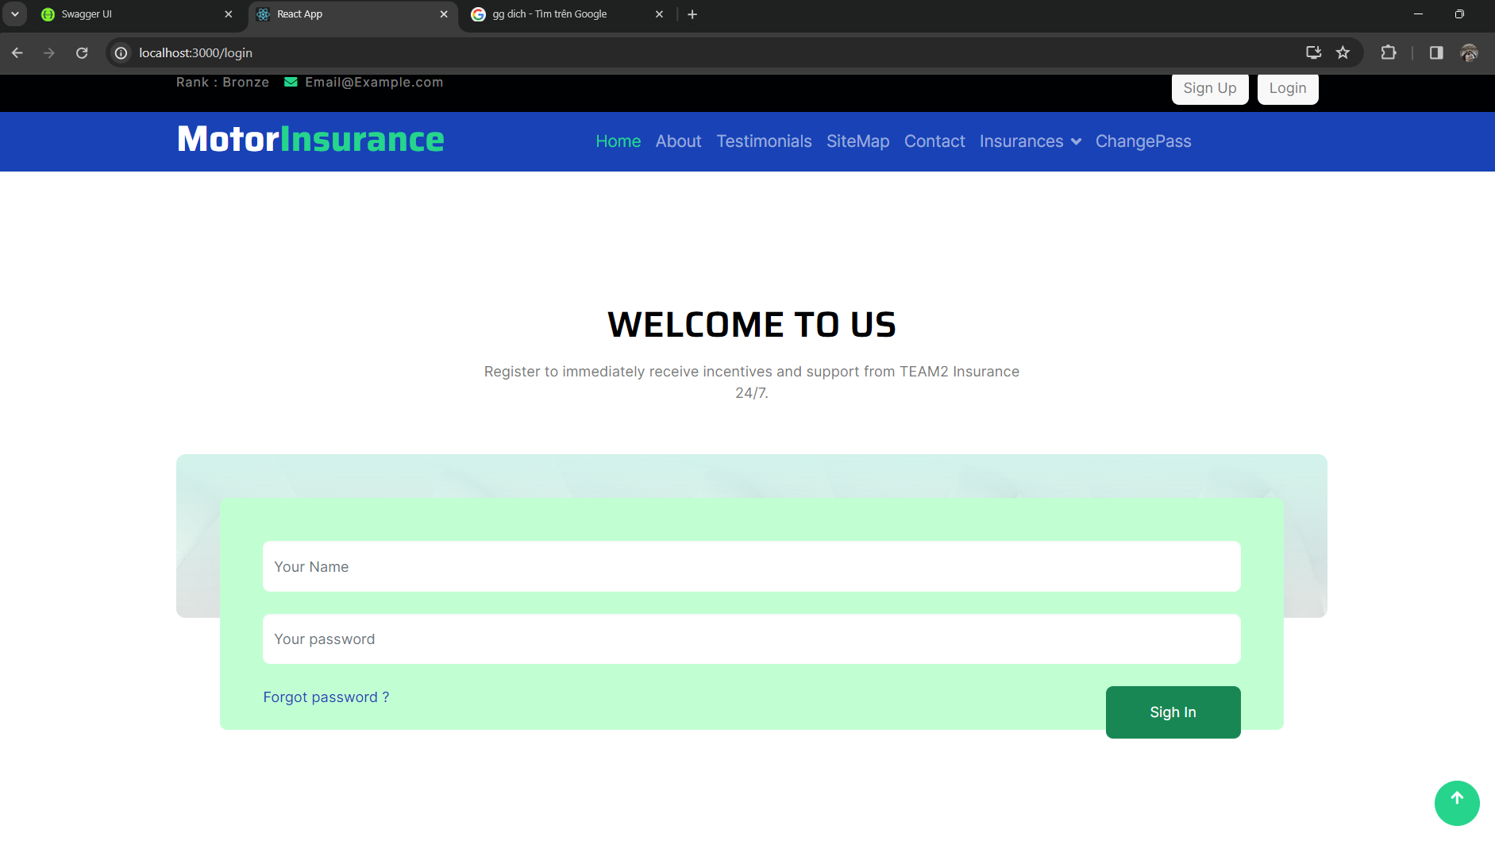

#### Category

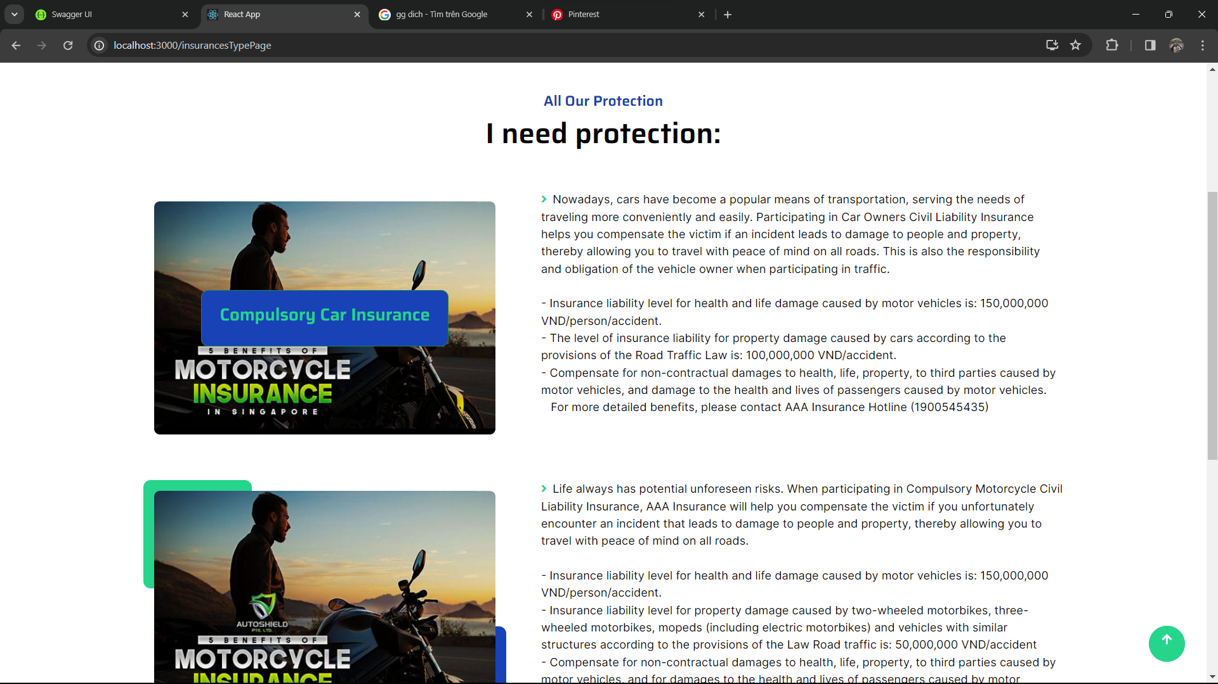

#### Order product

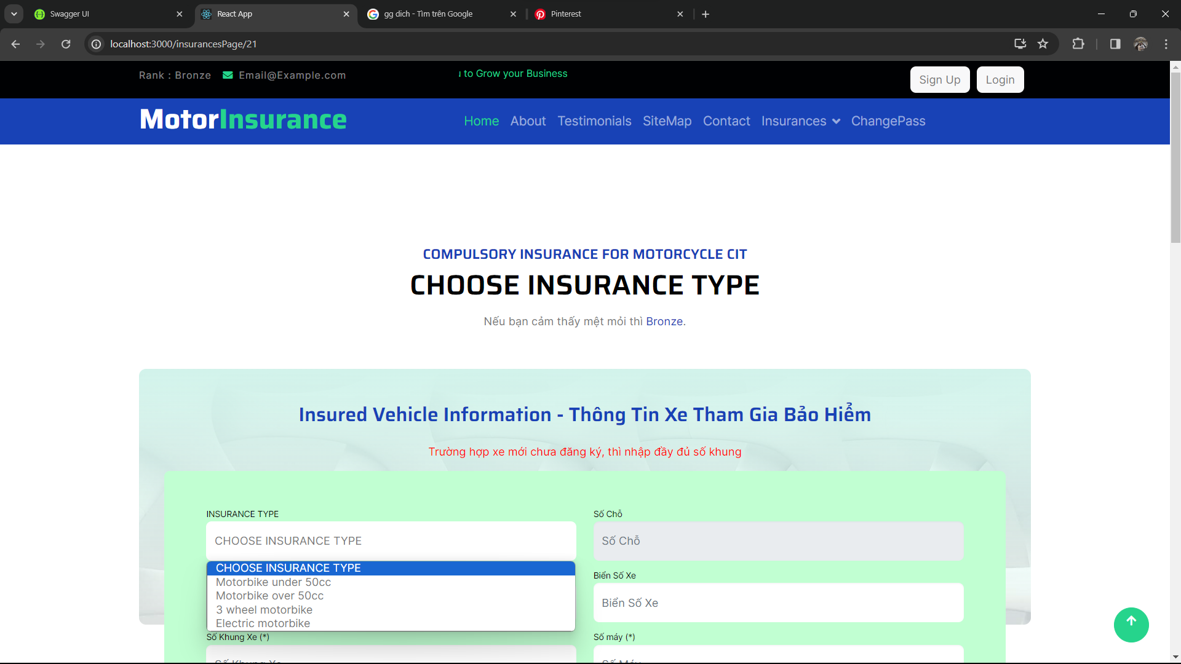

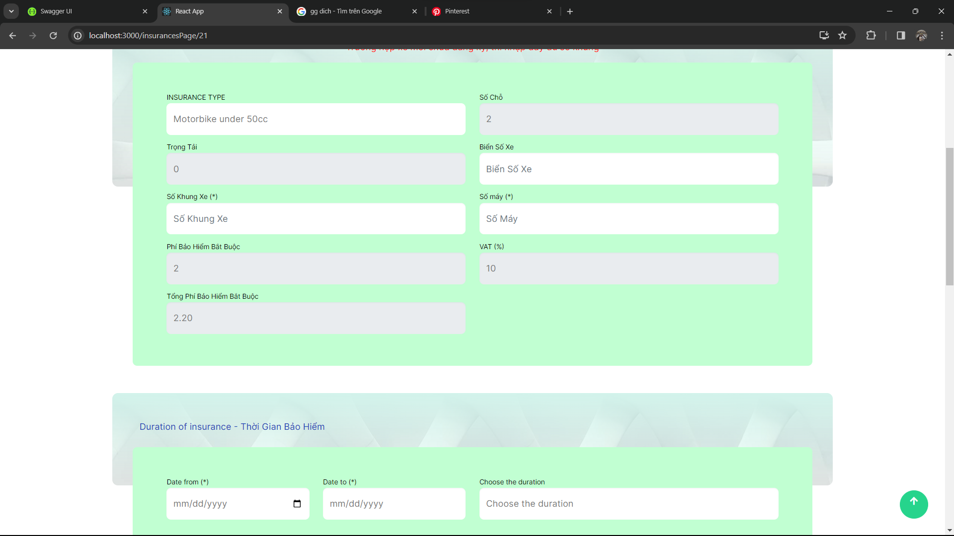

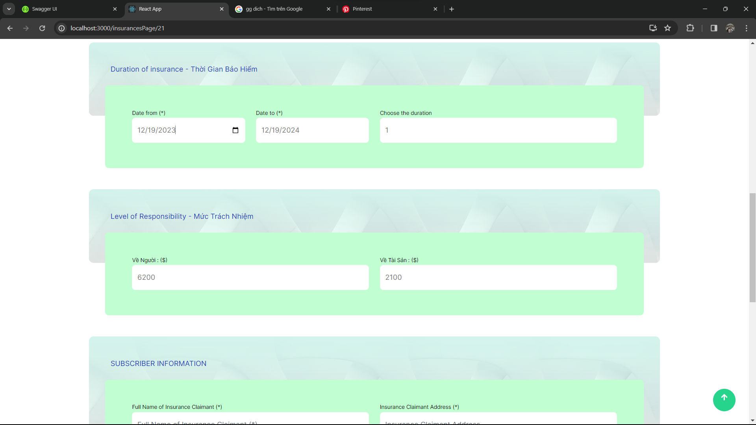

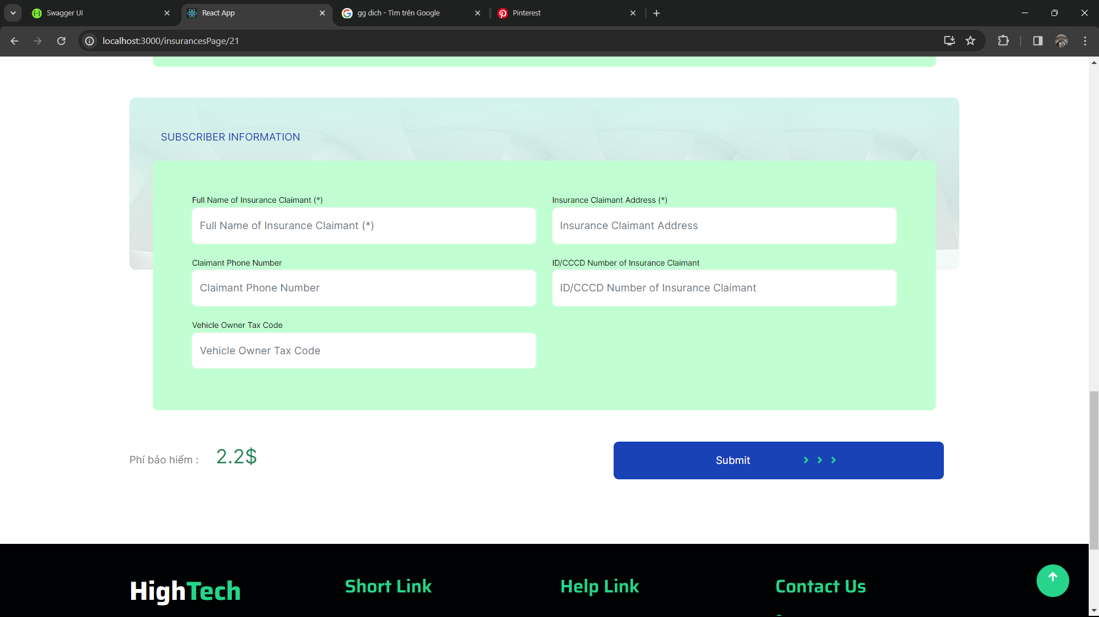

#### Wait for pay

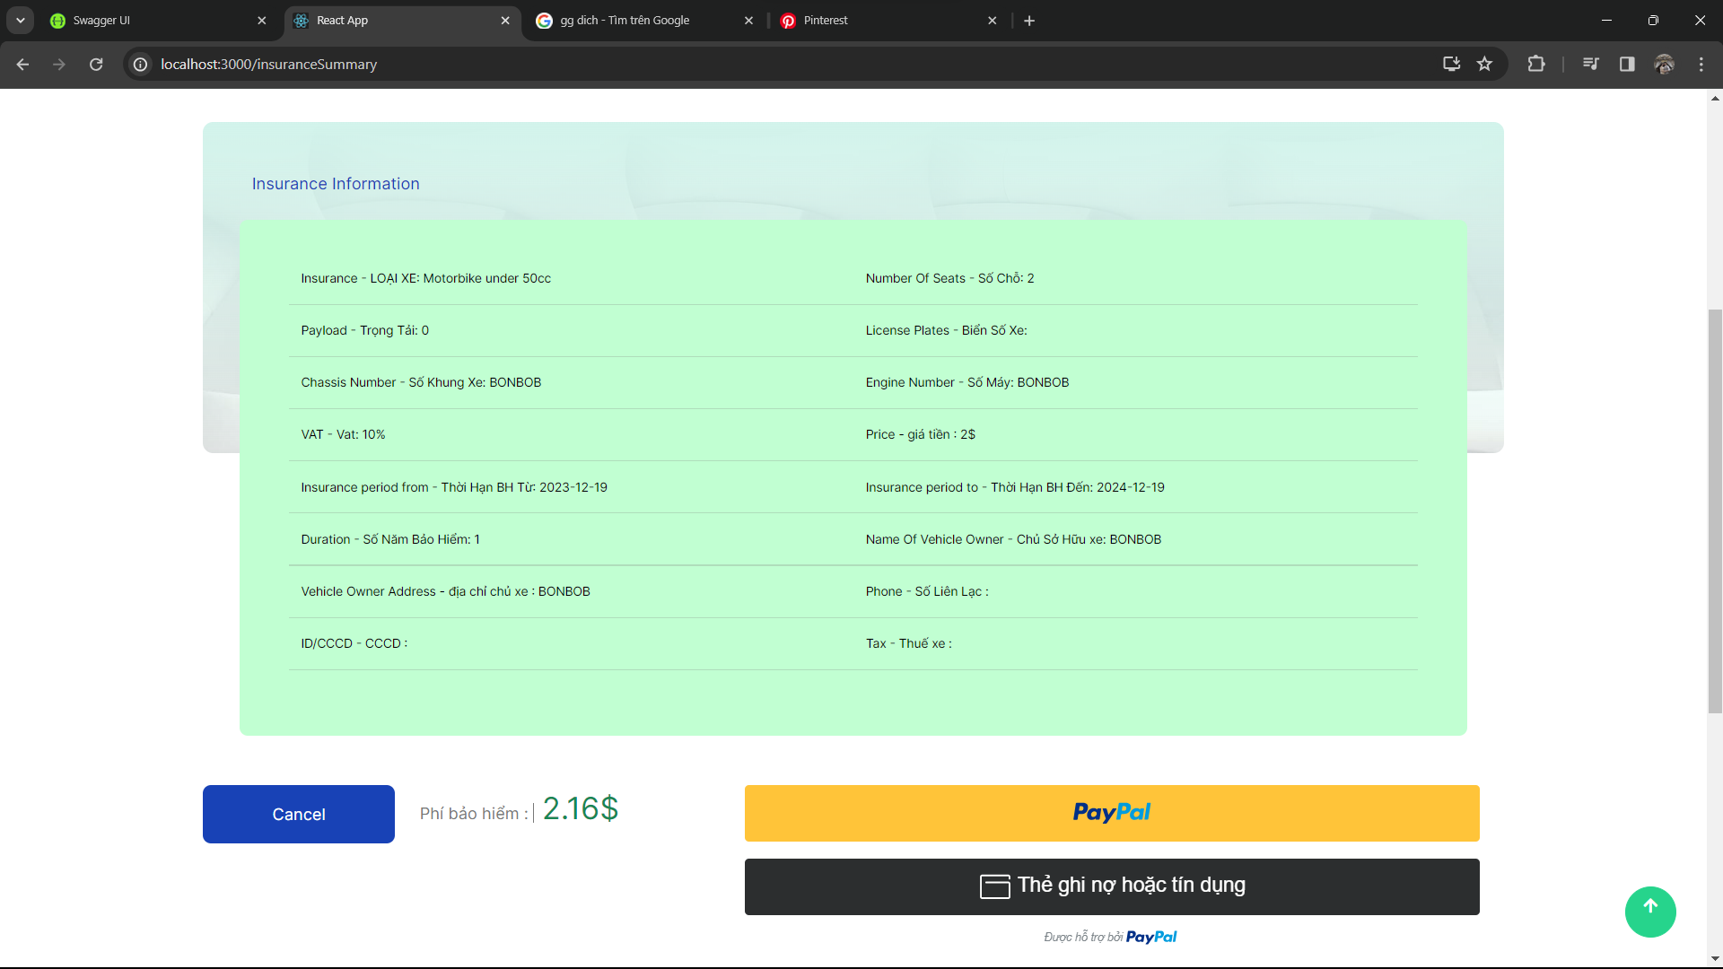

#### Order list

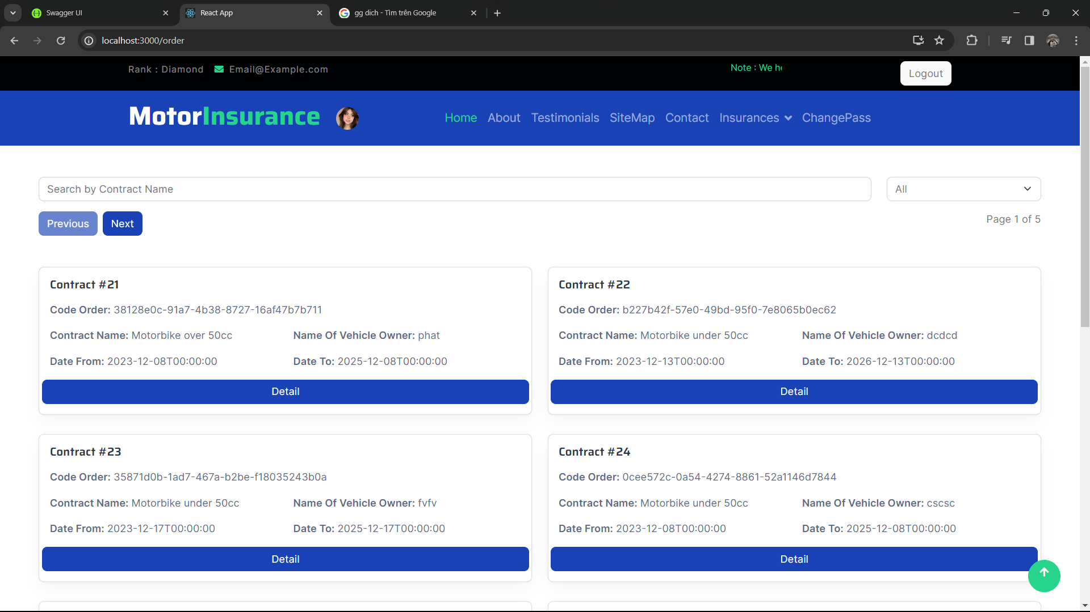

#### Order detail

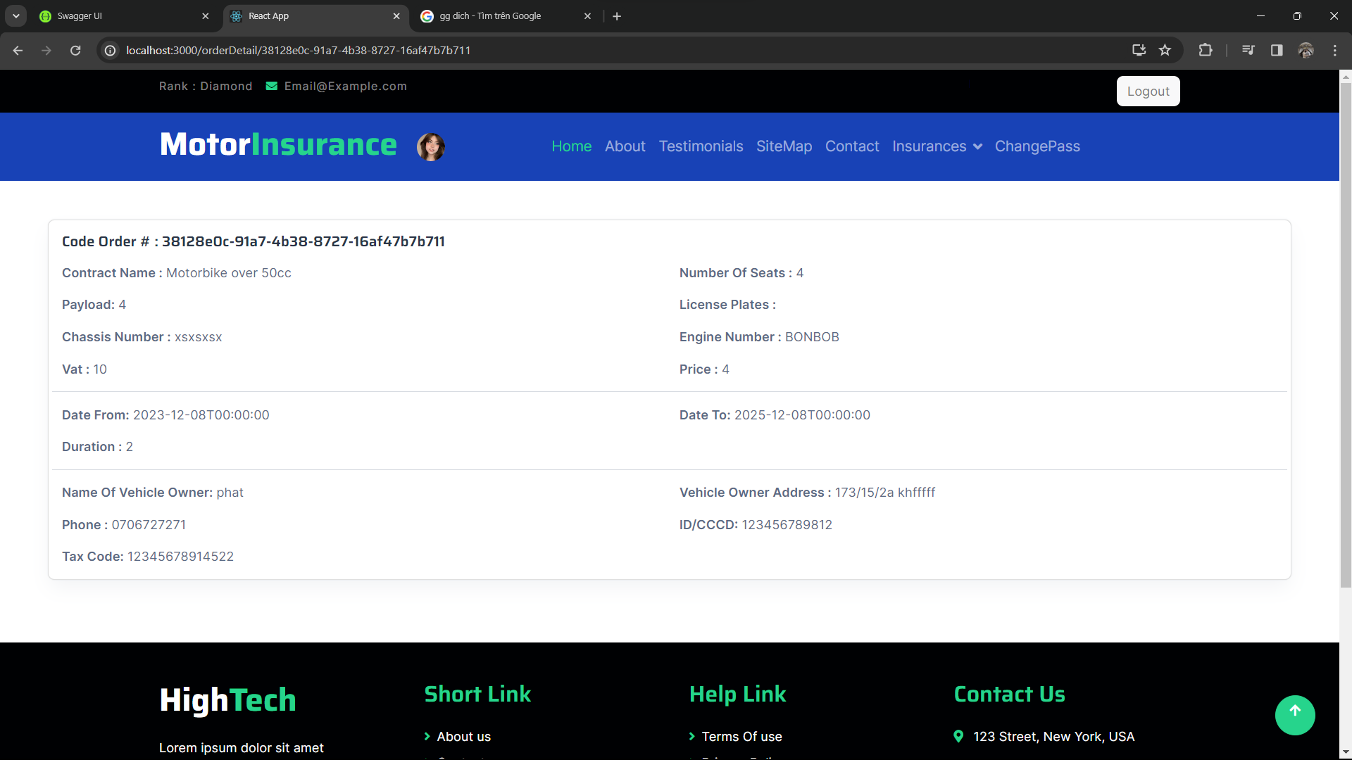

### Dashboard GUI

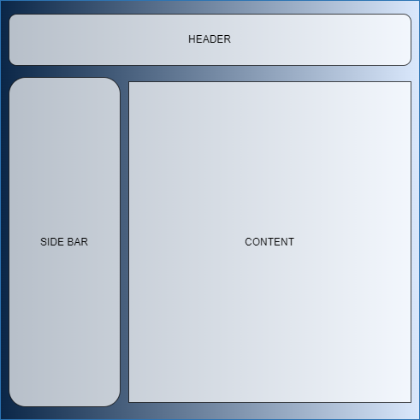

**Login**

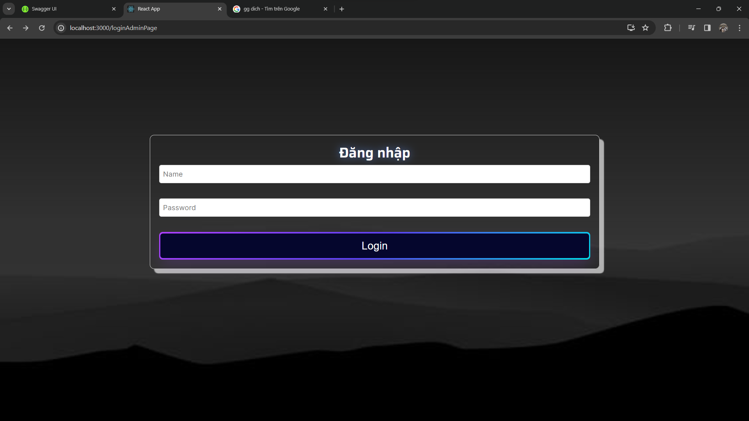

**Dashboard**

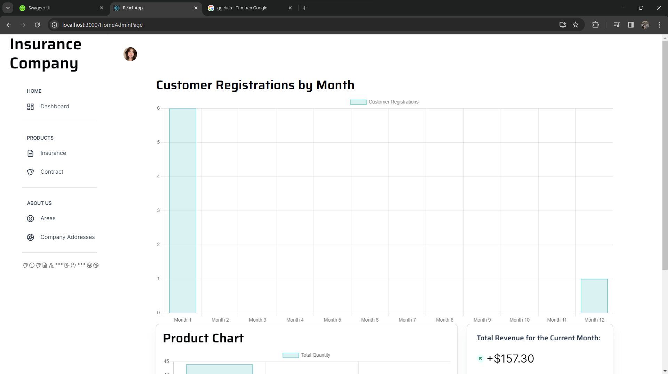

**Insurance**

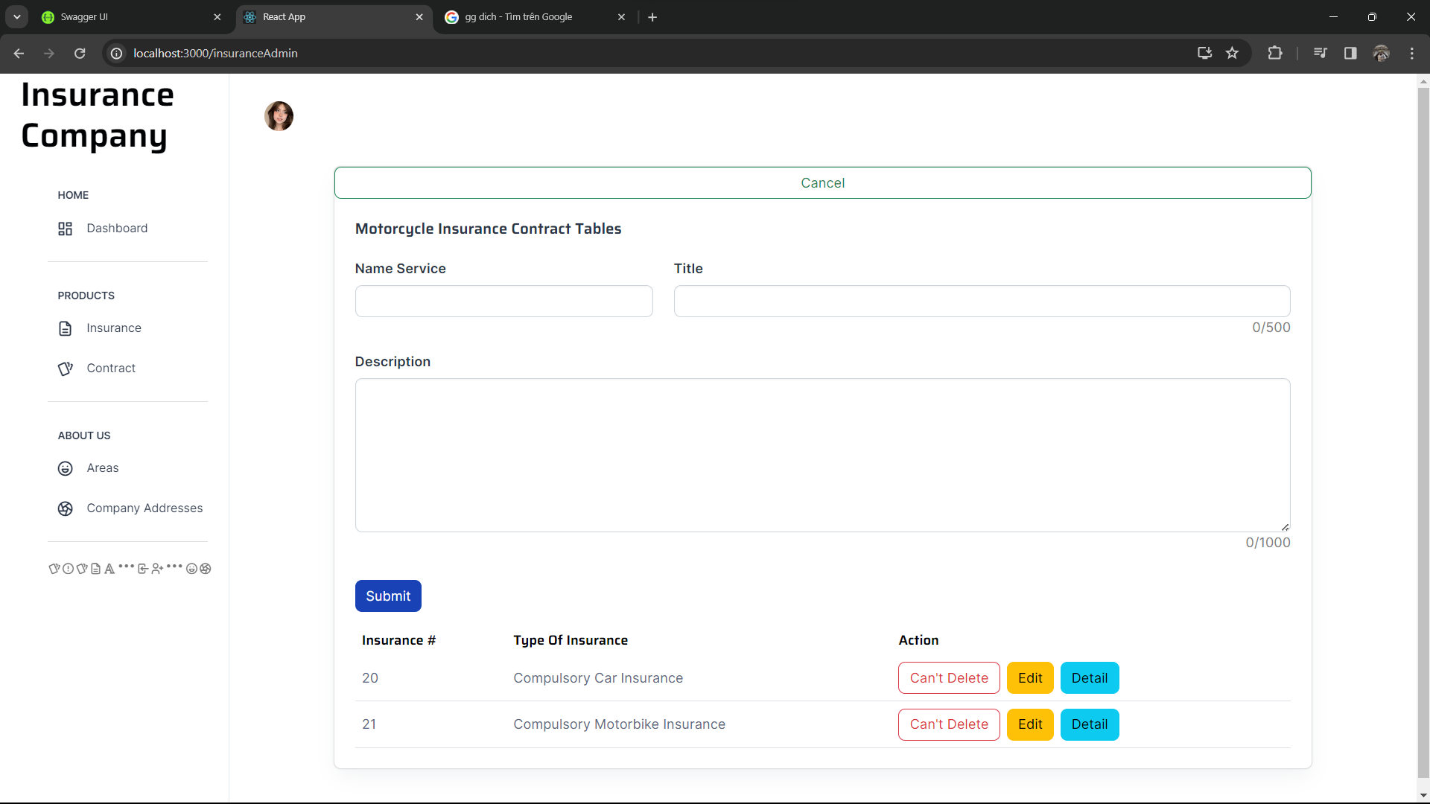

**Contract**

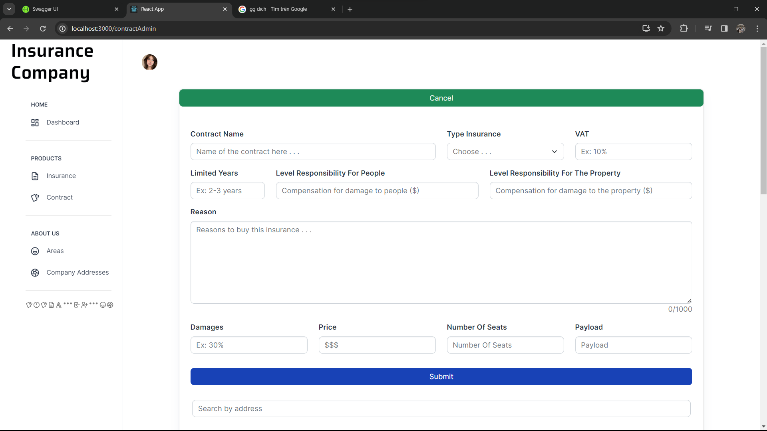

**Area**

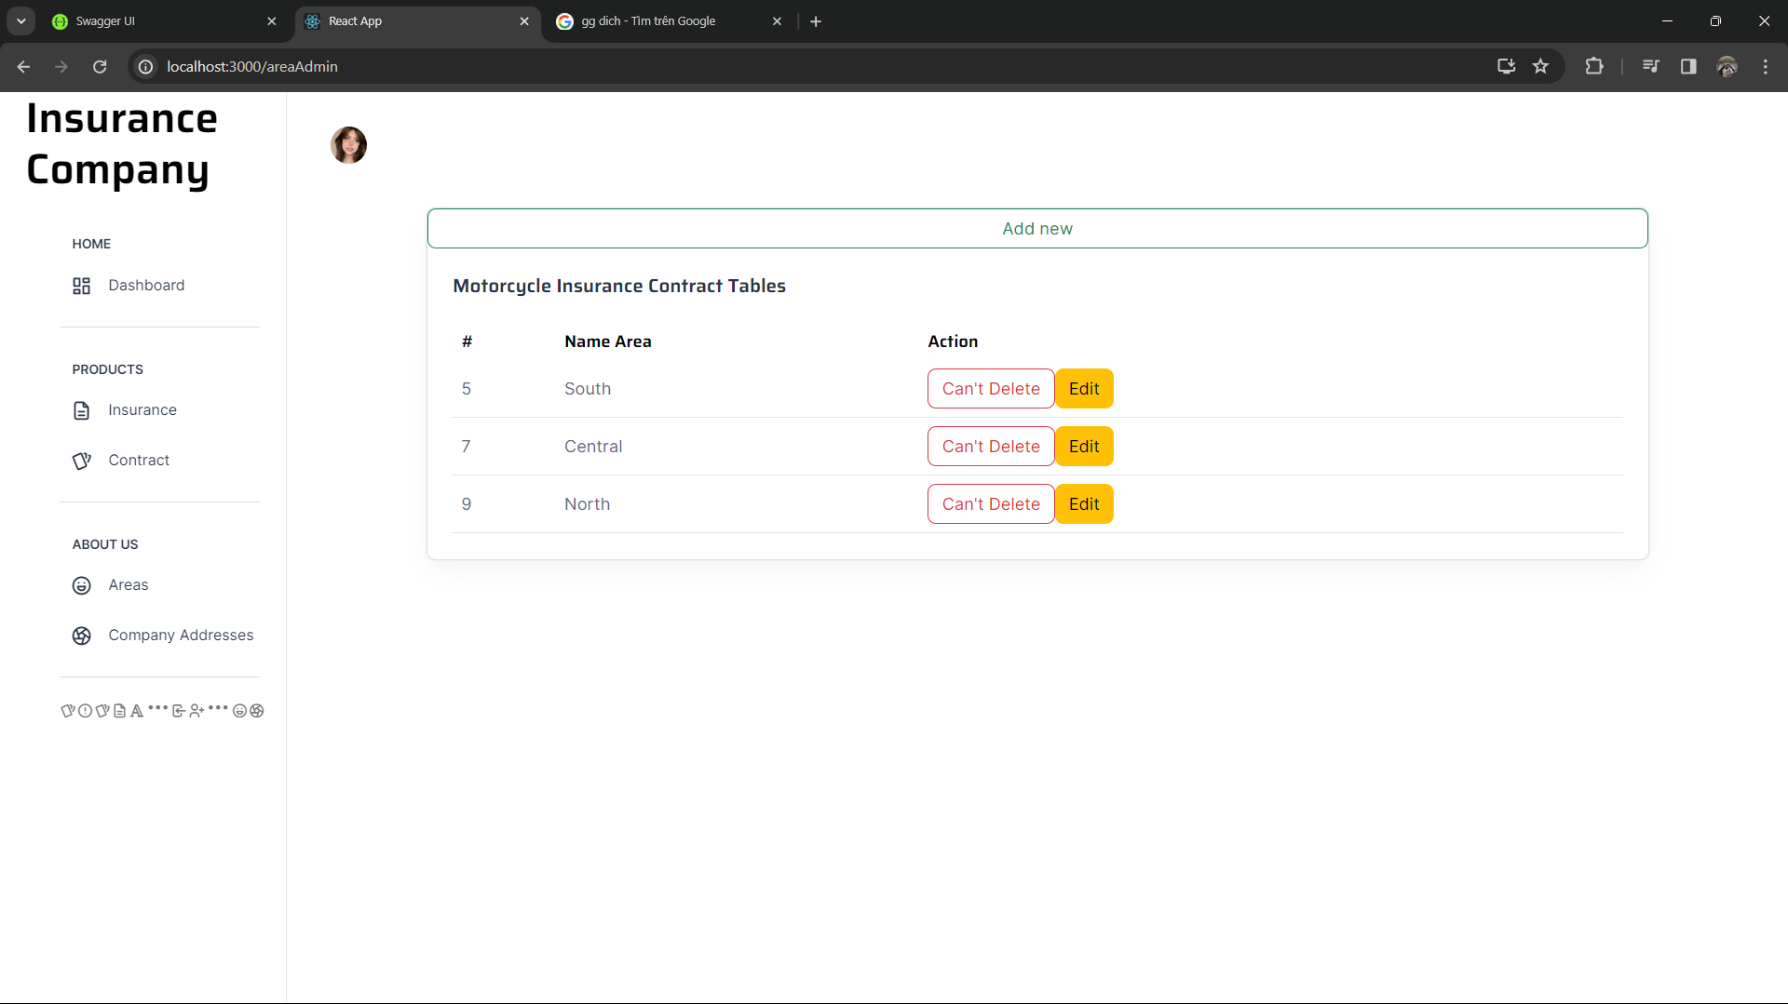**Address**

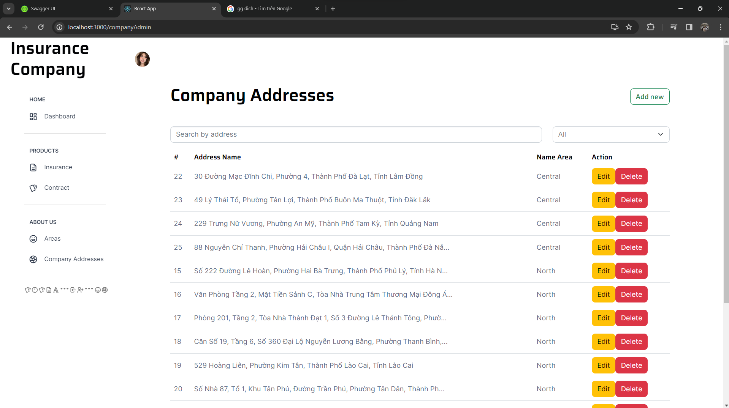

**TASK SHEET REVIEW 3**

|  |  |  |  |  |  |  |
| --- | --- | --- | --- | --- | --- | --- |
| **Project Ref. No.:** **eP/Advertisement** **Portal Management** **System/01** | | **Activity Plan** **Prepared** **By:** | **Date of Preparation of Activity Plan:** | | | |
| **Sr.No.** | **Task** | **Actual Start** **Date** | **Actual** **Days** | **Team** **Mate** **Names** | **Status** |
|  | CRUD product |  | 29/11/2023 | 1 | **TAN PHAT** | Completed |
|  | Order | 29/11/2023 | 1 | Completing |
|  | Category | 29/11/2023 | 1 | Completing |
|  | Paying | 29/11/2023 | 1 | Completing |
|  | Dashboard | 29/11/2023 | 1 | Completing |
|  | About | 29/11/2023 | 1 | Completed |
|  | Costs incurred (React) | 29/11/2023 | 1 | Completed |
|  | Decentralize authority to bosses and employees | 29/11/2023 | 4 | GIA PHUC | Completed |
|  | CRUD user, employee, boss | 29/11/2023 | 1 | Completed |
|  | Contact Be/Fe | 29/11/2023 | 1 | Completed |
|  | Signup | 29/11/2023 | 1 | Completed |
|  | Login | 29/11/2023 | 1 | Completed |
|  | logout | 29/11/2023 | 1 | Completed |
|  | ForgetPass | 29/11/2023 | 2 | Completing |
|  | Indemnify | 29/11/2023 | 15 | TIEN DUC | Completed |
|  | Costs incurred (API) | 29/11/2023 | 1 | Completed |

|  |  |
| --- | --- |
| **Date: 29/11/2023** | |
| **Signature of Instructor:**  **MR. LE TUAN XUYEN** | **Signature of Team Leader:**  **TRUONG TAN PHAT** |